**ADS ASSIGNMENT-1**

**Q1. Produce a line plot showing multiple lines with proper labels and legend. Describe what conclusions you can draw from this plot.**

CODE:

# Import the library

import pandas as pd

import matplotlib.pyplot as plt

"""

LINE PLT

"""

# Read dataset in file in csv format

energy = pd.read_csv('chicago_energy_benchmarking.csv')

print(energy)

# Plotting multiple lines graph

plt.figure(figsize=(7,7))

plt.plot(energy["Electricity Use (kBtu)"], label="Electricity Use")

plt.plot(energy["Natural Gas Use (kBtu)"], label="Natural Gas Use")

plt.legend()

# Adding the labels of X and Y

plt.xlabel("Data")

plt.ylabel("Total Emissions")

plt.show()

**Explanation:-**

The line graph shows the how much electricity and natural gas used by Chicago .Here, I choose two energy source from mentioned data set, I choose figures of electricity and natural gas used in Chicago and how much emission of the energy. In the chart we can see the most of use for the energy is electricity as compare to naturel gas. The line chart is shows data in billion numbers. So high use of electricity is 4.86E+08 and high natural gas use is 3.44E+08.

**OUTPUT:**

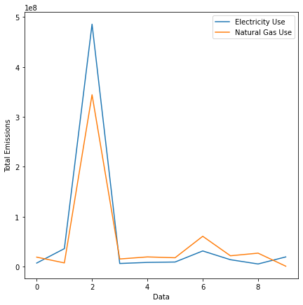

**Dataset Link:** <https://data.world/cityofchicago/chicago-energy-benchmarking>

**Q2. Produce graphs using two other visualisation methods. Explain why you picked this type of graph and describe what conclusions you can draw.**

1. **Pie Plot –**

* **CODE:**

"""

PIE PLT

"""

# Read dataset in file in csv format

cal = pd.read_csv('Nutrition_of_Fruit.csv', encoding="latin1")

print(cal)

# Add the labels in pie chart

name = ["Asparagus", "Bell Pepper", "Broccoli", "Carrot" , "Cauliflower", "Celery", "Cucumber", "Green"]

# Plotting pie chart with values

plt.figure()

plt.pie(cal["Calories"], labels=name, autopct='%1.1f%%')

plt.title("Total calories of all fruit and veges ")

plt.show()

**Explanation:-**

The pie chart illustrates the percentages of total calories contained by fruits and vegetables. It can be clearly seen that, broccoli and carrot contains the highest amount of calories which is 23.7% and 15.8% respectively. The reason to choose this chart for this particular data is that by using this can give the best visualization to find out the effective results for the dataset.

**OUTPUT:**

**Dataset Link:** <https://data.world/adamhelsinger/food-nutrition-information>

* **Histogram Plot –**
* **CODE:**

"""

HISTOGRAM PLT

"""

# Read dataset in file in csv format

covid = pd.read_csv('Covid_19_SG.csv')

print(covid)

# Plotting 2 histograms with plots

plt.figure(figsize=(8,8))

plt.hist(covid["Total Completed Isolation MOH report"], label="Total Completed Isolation MOH report", alpha=0.8, bins=5)

plt.hist(covid["Total Hospital Discharged MOH report"], label="Total Hospital Discharged MOH report", alpha=0.8 ,bins=5)

plt.legend()

# Adding the labels of X and Y

plt.xlabel("Number of patient")

plt.ylabel("Frequency")

plt.show()

**Explanation:-**

The program shows the situation of Singapore during Covid-19 times. Here, I have the histogram plots to showcase compares the figures of the patients completed the isolated MOH report and total numbers of patients are discharged MOH report. In this data the Covid-19 time isolation patients more than discharged people. So in the conclusion we can see the critical condition of that time.

**OUTPUT:**

**Dataset Link:** <https://data.world/hxchua/covid-19-singapore>

**Link of my Repo – https://github.com/Ds1801/ADS-Assignment1.git**